Order:
Breakfast menu(egg mr muffin+coke)
Kiddy cone

The percentage of calories from fat

food | calories | Calories non fat | Fat calories in fraction | %of fat calories
Egg mr muffin  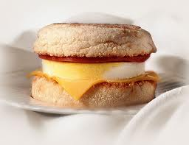 | 300 | 90 | 300-90=219  219/300=70/100=35/50 | 35/50x100%=  70%
Coke  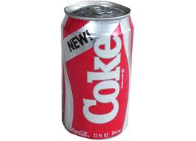 | 110 | 110 | 110-110=0 | 0
Kiddy cone | 45 | 35 | 45-35=10  10/45 | 10/45x100%=22 2/4%

menu | cost | counting
Egg mr muffin | $2
coke | $1.5
Original price | $3.5 | 2+1.5=3.5
Discount 10% | $0.35 | 10%=0.1  0.35x0.1
Price set menu | $3.15 | 3.5-0.35=3.15
Kiddy cone | 0.8 | 3.15+0.8=3.15
tax | 10% | 3.95x0.8=0.395
Total price | 4.345 | 0.395+3.95=4.345

